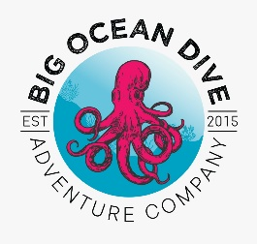
All standards are based on updates June 5th 2020 and Guideline from
DAN, Divers Alert Network
CDC, Center for Disease Control
EPA Environmental Protection Agency

DAN is the standard that all Dive Centers look to for information relating to diving and dive health. The endorsement that DAN has put in place for the Disinfection of Dive equipment and Gear relies on the EPA’s recommendations. Please refer to this website for a complete list of disinfectants for use against SARS-CoV-2 (COVID-19). https://www.epa.gov/pesticide-registration/list-n-disinfectants-use-against-sars-cov-2-covid-19
One of the products that is on the EPA list of disinfectants is Clorox Clean Up Cleaner + Bleach. This product is registered with the EPA # 5813-12. This # is on all containers that have the Clorox Clean Up Cleaner + Bleach.
The Clorox Clean Up Cleaner has Sodium hypochlorite 1.84 % and yields 1.75% available chlorine. According to the CDC this is more than adequate to kill the COVID-19. Bleach is typically only 5 to 6% of Chlorine.
The recommended use for the Clorox product is saturation for one minute according to the EPA and 30 seconds from the Manufacture.
Big Ocean Dive strives for and holds up to the highest standards for the safety of it customers.

Disinfection Protocol for Dive equipment:
- All employees of Big Ocean Dive will use only the products that meets the EPA’ s criteria for SARS- CoV-2
- For the use of Clorox Clean Up Cleaner + Bleach all parts of the scuba unit that comes in contact with diver will be saturated with product for one minute before being rinsed off.
- Before and after use- dive equipment will be disinfected.
- Customers will also be offered wipes that comply with the EPA’s recommendations.

